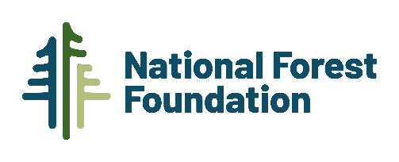
Email Template for friends and family

Subject: I’m fundraising for National Forests - please help me plant [#] trees!

Dear [Contact’s Frist Name],

As you know, I love nature, the outdoors, and public land. National Forests are a combination of all of these. But they need our help. These forests are losing trees to increasingly frequent disturbances, such as wildfire, insects, and disease. That’s why I am starting my own fundraising page [link] to help National Forests by planting trees.

I would really appreciate your support in this effort. Every $1 donated through my page will plant one tree on a National Forest in need of reforestation. To donate, simply open my [fundraiser name] page [link] and click “Donate.”

My goal is to raise [target amount] to plant [target amount] trees on a National Forest in need.

You may be wondering why I am fundraising for the NFF. The NFF works to engage Americans in promoting the health and public enjoyment of our National Forests and is the only organization that solely focuses on our National Forests. They have several programs to support their mission, but I am really excited about tree planting. They partner with the forest experts at the U.S. Forest Service to identify deforested areas where tree planting will provide the greatest ecological benefit. The Forest Service also provides a 2:1 match - for every $1 from the NFF, the Forest Service adds an additional $2 in value by sourcing seeds, providing the labor to plant trees and monitoring their long term survival.

National Forests are so important to me. [Add your personal reasons for supporting the campaign, such as: a memorable camping/hunting/backpacking trip, family time, hiking with your children/parents/grandparents, or your love for skiing/canoeing/trail running – whatever your reasons for loving National Forests, let your friends and family know how important these forests are to you and why you are personally supporting this campaign!]

National Forests provide us, wildlife, and the environment with so many benefits - from supplying millions with drinking water to filtering air pollution and providing 193-million-acres of habitat – so please be a part of my effort to help reforest these important public places. Every $1 counts, since every $1 is a tree that we will plant together. Please check out my fundraising page [insert link] today.

Thank you!

[Your Name]

